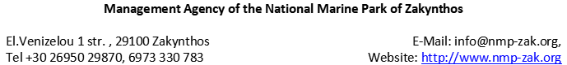
Lionfish Observation Form
Name of observer:___________________________  Profession: _________________________________ |  |  |  |  | 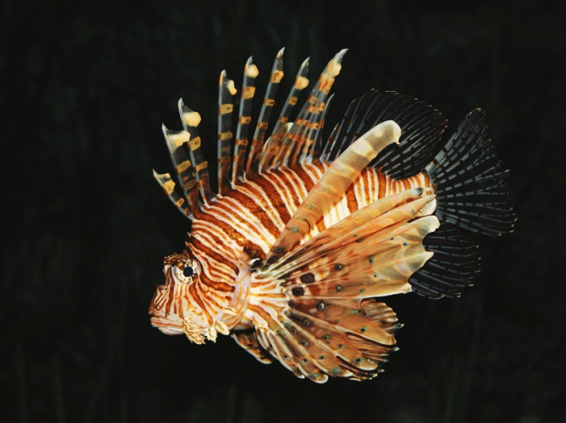
Are there photos of the observed lionfish ?
YES: NO:
If yes, please send them at the email address of the Management
Agency of the NMPZ.
 | Date of observation | Area of observation | Depth (m) | Number of fish |  | Longitude | Latitude | Fish Length (cm)
1
2
3
4
5
Status of lionfish during observation:  Alive  Number of lionfish spotted alive: ……….  Dead  Number of lionfish spotted dead: ………. |  |  |  | Method of observation:  Scuba Diving Net  Free diving Longline  Snorkeling Fished by boat  Spearfishing Fished ashore  Other:
Comments: |  |  |  | Please, indicate on the map the lionfish occurence according to the order of observation in different sites and dates (e.g. 1, 2, 3, etc):
1 |  |  |  | 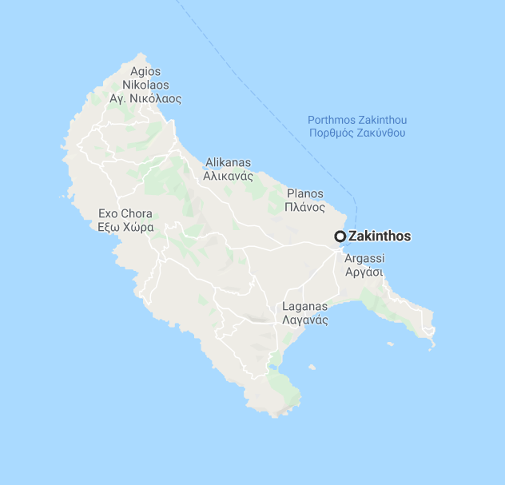
2
3
4
5

